
Koneru Lakshmaiah Education Foundation
(Deemed to be University estd. u/s. 3 of the UGC Act, 1956)
Off-Campus: Bachupally-Gandimaisamma Road, Bowrampet, Hyderabad, Telangana - 500 043. Phone No: 7815926816, www.klh.edu.in

STUDENT CASE STUDY EXECUTION REPORT
Department | FED
Subject | DSA-2
Academic Year | 1-111 Semester | 2025-26
Faculty Name | Mohd. Razia Alangir Banu
Student Name | M. Shravya
Roll Number | 2520030588
Branch | CSE
Course Outcome | CO 1
Case Study Topic: Course Catalog Management using Binary Search Tree (BST)
Work Done Summary:
In this case study, we implemented a Binary Search Tree (BST) to efficiently manage the course catalog of the Skill Bridge – Online Skill Development & Certification Platform. The BST organizes courses based on unique Course IDs and supports fast insertion, deletion, and search operations. The system enables efficient management of thousands of courses while maintaining sorted order.

Implementation Details:

1 Implemented BST insertion operation for adding new courses.
2 Stored course details using Course ID as the key.
3 Implemented BST search operation for locating courses quickly.
4 Implemented BST deletion operation for removing discontinued courses.
5 Performed inorder traversal to display courses in sorted order.
6 Analyzed BST performance for large course datasets

Result: Screenshots / Output

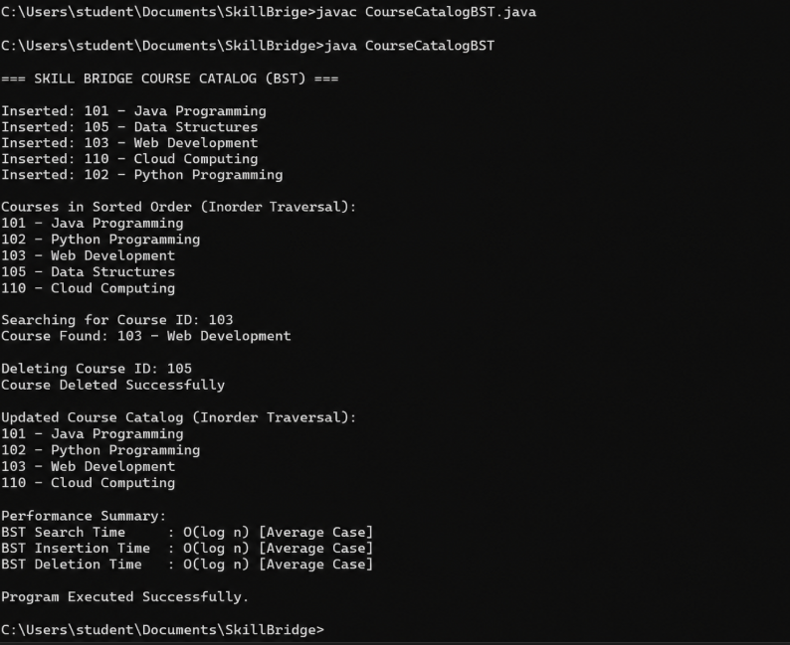

Time Complexity:
Operation | Complexity
BST Search | O(log n) Average
BST Insertion | O(log n) Average
BST Deletion | O(log n) Average
Traversal | O(n)

Result
The Binary Search Tree efficiently managed the Skill Bridge course catalog by supporting fast insertion, deletion, and search operations. The courses remained organized in sorted order based on Course ID, making retrieval and maintenance easier for large-scale online learning platforms.

GitHub Link:
Student Signature Faculty Signature

